**LockBox For Children**

*Jadon Donais*

*Shamarke Hassan*

*Curtis Ficor*

**Project Description:**

Excessive phone use in children is creating a future that is drastically impacting our lives. Exposure to phones early with no sense of control can form a dependence, leading to mental laziness and the need to feel instantly gratified. As a result, this impacts our ability to build a strong foundation for our lives. Some areas that it can impact are the ability to appreciate life, sleep quality, building healthy habits, recognizing how you are feeling, child-parent interaction, and being rewarded for painful things.

This solution is a physical systematic process that will build a strong foundation improving the long-term quality of life: Before the child goes to sleep, they put their phone in an Automatic LockBox that activates a display screen for the user to select the time they would like to wake up at in the morning. After that, the user will select the activities they would like to do in the morning. After confirming, the user will say one thing they are grateful for before bed. Once done the box will close and lock automatically, then the user will go to sleep. While sleeping their sleep will be monitored. In the morning the user will be awakened and will need to complete their activities selected the night before. When done, the user will select how they feel, and draw where they feel this on a body map. Lastly the parent will come and verify the tasks are complete, which will unlock the box for the user to get their phone back, and they will be able to see all the data on their phone via the *EmotionMirror* app. All the technology is situated in this box.

**Project Specification:**

* Measure data from sensors

- Temperature sensor range 0 - 40 degrees C

- Humidity Sensor range 20% - 60% humidity

- Light Sensor range 5 to 1000 lux

- CO2 Sensor range 0 - 2000 ppm

* Send measured data to database for storage

- Every 24 hours

* Automatically lock when phone is placed inside

- < 5 seconds to lock

* Charge and UV clean phone while inside box

- 5 Watt wireless charging

- 2 x 2 Watt UV bulbs

* Allow user to navigate and select using pushbuttons
* Display text through LCD screen

- Raspberry Pi I2C serial interface adaptor

* Detect and record voice through microphone

- Range of < 1 metre

* Box(alarm clock) activates using speaker, LEDs and LCD
* Software to quantify sleep quality using measured data

- Data measured at least every 30 minutes

* Sending data to database for *Emotion Mirror* app

- Data parsing

* Safely interface devices from 120VAC

- AC to DC converter (120VAC to 3.3-12VDC)

**Testing Plan:**

Testing methodologies that will be implemented will be Unit Testing for individual components and afterwards Integration Testing for the system.

* Measure data from sensors

- Ensure sensors can measure within ranges specified in datasheets

* Send measured data to database for storage

- Use timer to ensure data is sent within timeframe

* Automatically lock when phone is placed inside

- Use stopwatch to time the duration lock takes to lock

* Charge and UV clean phone while inside box

- Use DMM to measure the voltage and current of charger when load is placed

- Bacterial swab to test if phone is cleaner after 5 minutes in UV case

* Allow user to navigate and select using pushbuttons

- Test if buttons press corresponds with display output

* Display text through LCD screen

- Display accurate time through display ( < 2 second delay)

* Detect and record voice through microphone

- Test that mic can reliably convert speech to text up to 1 metre away

* Implement alarm clock using speaker, LEDs and LCD

- Set 5 minute alarm and use stopwatch to ensure correct timing

* Software to quantify sleep quality using measured data

- Test that data is sent to database immediately after alarm goes off ( < 5 seconds)

* Sending parsed data to *Emotion Mirror* app

- Consult with app developers

* Safely interface devices from 120VAC

- Use DMM to measure the input and output voltages

**Workload Plan:**

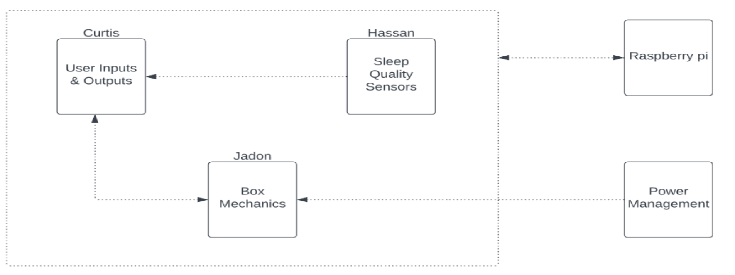

* Curtis: Pushbuttons, Drawing pad display screen, Microphone, Mic-on LED, Speaker, LCD Screen, LED Strip, database communication for EmotionMirror App, 3D box design
* Sharmarke: Temperature Sensor, Humidity Sensor, Light Sensor, CO2 Sensor, Motion Sensor, RFID card reader and Fob, sleep quality quantify software
* Jadon: Electronic lock, Limit Switch, AC/DC converter, Wireless charger, UV clean, 3D box design

**Other requirements:**

Machine Learning using values stored in the database:

- Our advisor recommended using machine learning algorithms once the data is properly stored and organised in our database.

**Gantt Chart:** 